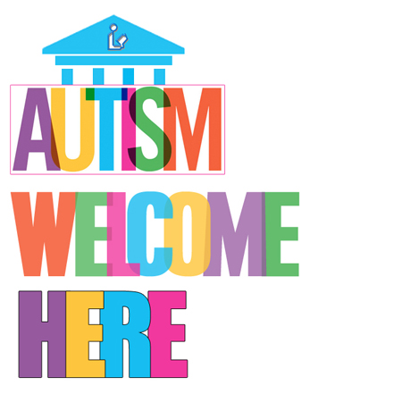
2018 PRESS RELEASE
Applications will be accepted for the
“Autism Welcome Here: Library Programs, Services and More” Grant
Grant applications accepted starting September 1, 2018
www.librariesandautism.org/grant
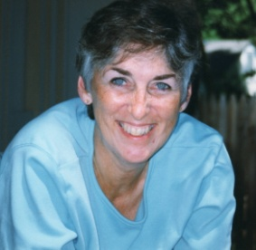
This grant honors the groundbreaking work of Libraries and Autism: We’re Connected co-founder, Meg Kolaya, for her contributions in promoting inclusion, connecting libraries with the autism community, and bringing awareness of the needs of individuals with Autism Spectrum Disorder (ASD) and their families to the library community.
GRANT DESCRIPTION

For the fourth year, this grant will award a total of $5,000.00, with all of the funds either going to one
proposal or the amount
divided among several applicants, depending on the applications received. All types of libraries, either in the United States or Canada, are encouraged to apply, and proposals will be eligible that fund projects and/or services directed at any age group. Applicants may propose to initiate a new, creative program or service, bring an established, successful program or service to their library for the first time, or enhance a program or service that they currently offer. All proposed projects must benefit people with autism or their families, directly or indirectly. Funds may be used to hire a trainer to present a workshop, buy program materials, pay for staff coverage, etc., so long as these expenses further the library’s ability to serve people with autism through the proposed initiative.

SEE THE PREVIOUS GRANT WINNERS AND THE PROJECTS THAT WERE FUNDED HERE: www.librariesandautism.org/grant/GrantWinners.htm

DATES
Applications will be accepted starting September 1, 2018.
The application deadline is December 1, 2018.
The winning applicant(s) will be notified by March 1, 2019.
The grant-funding period is from April 1, 2019 – March 31, 2020.

CRITERIA FOR SELECTION
- The project is clearly described and well thought out.
- The potential impact is significant.
- There is institutional support for the program or service.
- People with autism, family members or other community stakeholders are involved in the development and/or implementation of the project.
- The program is one that would be replicable in other communities.
- The program or service is based on an understanding of the needs of people with autism and/or best practices in working with this population.
- There is a plan for the continuation of the service or program after the grant year.
- The project would not be possible without outside funding.

GRANT FORMS: The following 2019 grant forms can be downloaded at www.librariesandautism.org/grant:

- The Grant Application - All questions must be answered, unless they are marked "optional”
- The Grant Sample Budget Sheet –All budget items must also be included in the grant narrative
- The Grant Report Guidelines -Applications, budget sheets, institutional letters of support and other supporting documentation must be submitted as email attachments to: grant@librariesandautism.org

